4 On 3 Overload Drill
In the game of basketball, there are many situations where you have to scramble and match up with players; like rotating out of help defense and in transition. This is one of the best drills to improve your ability to scramble and match up.
Your defense is at a constant disadvantage and it forces them to hustle, communicate, and rotate.
In this 4 on 3 situation, someone will always be open, but with good positioning and effort you can keep things under control. This drill can also be done as a 5 on 4 type of drill.
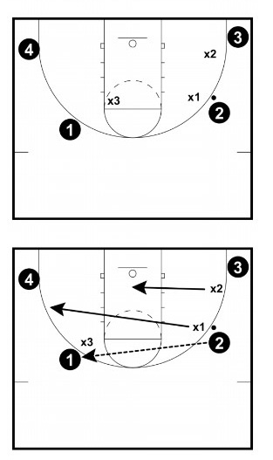

Set Up:
You start with three defenders and four offensive players.
The ball starts on the wing.

Instructions:
As the ball is passed, defenders have to leave their player, scramble to cover the ball or be in a good help position.
The ball can be skipped and players are allowed to dribble penetrate in their areas (but are mostly stationary early on as you learn rotation).
After you get the hang of rotating and scrambling, you go "live" and the offense looks to score.

Points of Emphasis:
- Effective Close Outs - If you are not going all out on our close outs in this drill, you will be exposed pretty quickly. You are already down in numbers, if someone isn't closing all out and under control, you are beaten before you even start.
- Sprint To Areas / Effort - Hold people accountable on effort. Make sure they are sprinting to areas.

Coaching Tips
- Progress To More Situations and Increase Difficulty - After you are satisfied with the concepts sinking in, you can allow the offense free movement, interchanges, screens etc.

