Five on Five Whistle Change
This drill works on your defenders' ability to scramble and pick up a different player when a game situation forces them to do so. This often happens in transition and rotating out of help defense. Communication is a must in this drill and your players will be forced to improve.
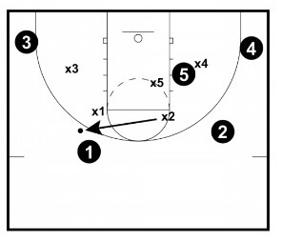

Set Up:
You start with five offensive players and five
defensive players.
They are matched up five on five.

Instructions:
You start playing five on five live.
On the whistle, the offense will set the ball down on the ground.
Someone on defense (anyone but the player who was guarding the ball), has to pick the ball up. X2 is picking it up in the diagram.
When the X2 picks the ball up X2's team is on offense.
The team that sets the ball down (in black) must scramble to guard someone. They cannot pick up the player that was guarding them. Example, 1 in black could not pick up X1.

Points of Emphasis:
- Communicate! - Players must communicate in this drill. If they don't, they will fail. Forcing players to talk and think on their feet as they scramble is making practice harder than what they will likely face in a game situation. Anytime you can do that in a drill, your team stands to benefit in the game.
- Stop the Ball - Even though players are matching up in the drill, they must be aware of the ball handler. The ultimate goal is to stop the offense from scoring, so help defense must be alert and stop the ball when necessary.

Variations:
Full Court - You can also play the game full court as a variation. You don't even have to start in a half court setting. Make sure to keep the team's baskets the same, though.

Coaching Tips:
- Variety - Make sure to vary who has possession of the ball and the location of the ball when blowing the whistle.
- Keep Coaching Defense - Keep coaching proper defensive fundamentals throughout the drill. Make sure that they close out properly, maintaining good position, rotate on help, defend screens properly, etc.

