Man in the Hole
Even if you play half court or quarter court defense, this should be a staple for every coach. This is a great 1 on 1 transition drill that works on your ability to stay in front of a ball handler in the open court. You work on the shuffle, the quick turn, running, and the turn and sprint to recover.
Additionally, it's great for conditioning and building mental toughness.
It not only improves your 1v1 full court defense, it improves overall athleticism and conditioning. When you have to shuffle, sprint, change directions over and over, you're going to improve athleticism and reaction time.
Even zone defense coaches use drills like these because of the tremendous benefits that they produce.
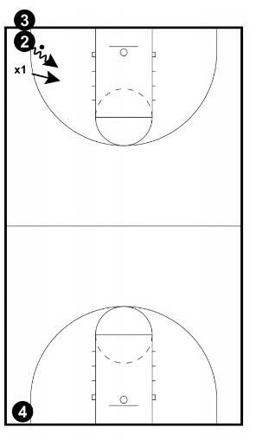

Setup:
The ball hander (2) has the ball on the baseline.
The defender (X1) is standing in front of the offensive player ready to play defense.

Instructions:
The offensive player (2) tries to beat the defender (X1) down the floor.
The defensive player tries to stop the ball handler from advancing the ball.
After the ball handler (2) makes it to the other end, they will hand off to 4, who will be facing the same defender X1, back up the court towards player 3.
3 is the last ball handler. X1 defends for the third and final time.
X1 is now "out of the hole" and you rotate to the next defender. X1 is now the next ball handler.

Points of Emphasis:
- Stop The Ball - The number one goal is to stop the ball from advancing.
- Push Step & Sprint - The defensive player should push step (shuffle) and sprint to contain the ball handler. If the defender gets beat, they need to turn and sprint to a spot to cut off the ball handler.
- Offense Practices Good Habits - The offense also needs to focus on good habits of protecting the ball and using effective change of pace and change of direction moves.
- Go Back To Where Defender Was Beat - If the offense gets by the defender, don't let them just turn and jog to the other baseline. Have the defender and offensive player go back to where they got beat. This will ensure focus and effort to stop the ball.

Coaching Tips:
- Encourage Players - Encouragement and energy from the Coach can help keep a player going in a drill like this. Get involved and work with them!
- Split The Court - Be sure to split the court into alleys. You can set up three to four alleys on each court. This allows you to work the entire team with this drill. You can use cones or other lines on the court.

