Purpose of the Drill:
Good warm up that works on ball handling full court, change of directions, and either layups or jumpshots off the dribble.
Instructions
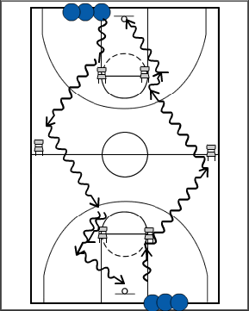
- Start lines at baseline opposite each other
- Each player dribbles to each chair and uses a change of direction to get past the chair
- Each player finishes with either a layup or jump shot or whatever the coach instructs
- After scoring, each player gets into the next line.
Points of Emphasis:
- Staying low with their dribble
- Approach each chair and do the move properly (fatigue will set in and lack of detail will happen.
- Make sure not to crowd each other.
- Keep your eyes up!!
- If using shooting to score. Work on either proper 2 step finish into jumpshot UNDER CONTROL.
- Have each player count their own makes. When time runs out, have them meet at 1/2 court and one person (a leader or someone who wants to start leading more) tallies up the makes and reports to the coach

