Purpose of the Drill:
This drill forces the ball handler to beat two defenders. It improves ball handling and the ability to escape and beat the double-team.
Instructions
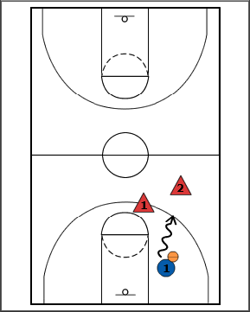
- 1 Starts on the baseline with the ball. The two defenders try to trap and/or stop the ball.
- 1 tries to beat the defense and score at the opposite hoop.
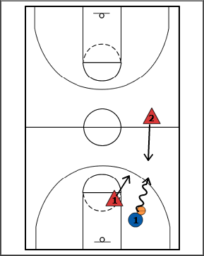
- You can also start this drill by having one defender force the defender to the baseline and bringing the 2nd defender to trap.
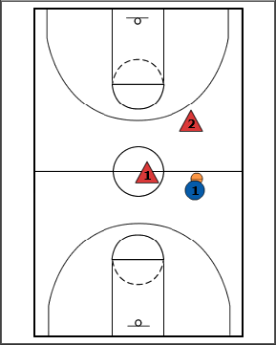
- You can also start at half-court, 3/4 court.
Points of Emphasis:
- To increase difficulty you can:
- Split the court in half.
- Restrict dribbles.
- Add a 3rd defender.

