Use the volleyball court lines or set up cones to create a boundary. In this example, the game will be played 5 on 5. However, depending on your numbers, you can play 3 on 3, 4 on 4, etc. Offense must complete 10 passes in a row without fumble, travel or going out of bounds. If ball gets knocked down, other team takes it and starts passing right away. In order to receive a point for a successful pass, the person who catches the ball has to call out the number. This forces every player on the team to communicate and not just the "loud player" on the team.
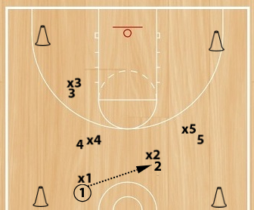
Ideas for additional rules and challenges
- After a turnover, you must touch an end-line before coming back in.
- After you pass, touch the end-line before you can do anything.
- Must touch end-line of court before coming back in.
- Any time you "statue" with the ball, it's a violation. You must be in triple threat and use your pivot.
- One second rule. You must pass or dribble within 1 second or it's a violation.
- Adjust the space of the playing area (smaller or bigger) to adjust the difficulty level.
Drill Variations
- The color your hand is touching on the ball, you have to touch that color dot on the court.
- Give each player a basketball. Play the same game but now they must dribble with their non-dominant hand while passing the small ball with their strong hand.
- Try to score the small ball (5on5 full court) while dribbling the regular basketball.

