This drill not only teaches your players how to pass out of a trap and develop toughness with the ball -- but also teaches your defensive players how to trap the ball.

Instructions
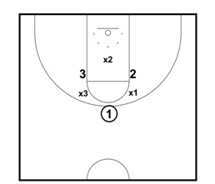
The drill starts out with six players forming a circle. The drill should last about 15 seconds. Switch the offense and the defense once play ends.
The offensive players cannot leave their spots.
The defense is allowed to move anywhere within the circle to intercept any passes.
When play starts, the two nearest defenders (X3 and X1) trap the ball. X2 plays the passing lanes to both 2 and 3.
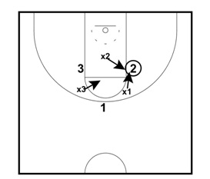
X1 and X2 trap the ball when the ball goes to 2. X3 plays the passing lanes to both 1 and 3.

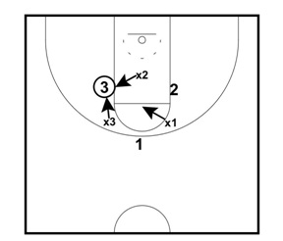
X2 and X3 trap the ball when the ball goes to 3. X1 plays the passing lanes to both 1 and 2.
Allow the players to "play" for a set amount of time. You can reward players for maintaining possession for the duration of the drill.

