"Pass and Replace" is a terrific multi-purpose basketball drill that will help players improve their passing, pivoting, finishing and is a great conditioner as well.
Instructions
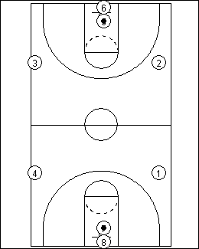
- Position 4 players on the sides of the court, approximately 28' from each endline. There should be a player on both sides of the court and on each half of the court.
- The rest of the team should be equally divided and in a line under each basket.
- There should be a ball in each line.

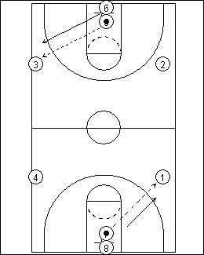
- The drill starts with the players with the balls passing, to the right, to the player at the 28' marker.
- The passer then sprints to replace the player he passed to.

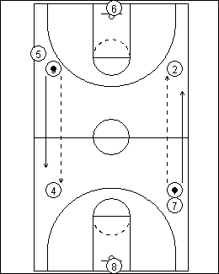
- The receiver pivots and passes to the next player at the 28' marker on the other half of the court.
- The passer then sprints to replace the player he passed to.

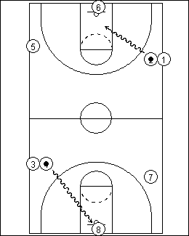
- The receiver pivots and drives to the basket and tries to score on a 1 dribble lay-up.
- The same action works on the other side of the court at the same time.

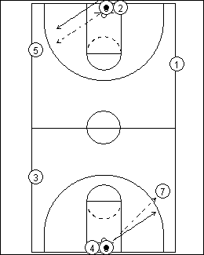
10. The next player in the line under the basket grabs the rebound, passes to the next player on the 28' marker and starts the action again.
We run this drill for 5 minutes with a goal of 100 made lay-ups. Each time we make the goal, we increase the goal by 4 made lay-ups. The drill can be run for more or less time and you can add a third or even a fourth ball. Adjust your goal appropriately.
You can improve the effectiveness of the drill by using particular passes (overhead, bounce, etc.) and pivots (drop step, front pivot, etc.) and direction of turn (inside, outside). You can use one set (overhead pass, drop step pivot, outside turn) for the whole drill or you can actually change one or more of the elements each minute.

