Drill Purpose (All Ages)
This drill is meant to simulate high speed, game-like situations to help players improve passing speed and accuracy. It's also a lot of fun for players because it's fast paced!
Note: This drill is set up for 8 players. If you have more players, use more court space.
Instructions
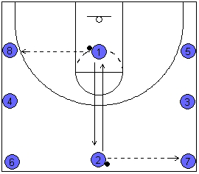
- Each player has a partner:
1 - 2
3 - 4
5 - 6
7 - 8
- Players 1 and 2 will start with a ball.
- Player 1 and Player 2 will pass the ball to their right.
- After passing the ball, they sprint to exchange places with their partner.
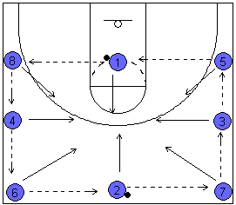
- The drill should keep moving quickly and all players will immediately pass ball to right then switch with their partner. As the both balls go around the court, players must sprint and beat the ball.
Points of Emphasis
Continually tell your players...
- Make accurate passes.
- Move as quickly as possible without sacrificing form and accuracy.
- When passing, step toward your receiver.
- When catching, extend your hands and step toward the pass.
- As in shooting, the ball should have backspin on it. This is accomplished by following through on every pass.

