3 v 2 + 1 is a very effective small sided game that improves numerous skills, team offense, and team defense. The specific area you improve depends on what you choose to emphasize during the drill. From an offensive standpoint, this drill can improve:
- Shooting
- Lay ups / finishing
- Decision making
- Passing
- Spacing
- Dribble drive movement
On the defensive end, this drill can improve:
- Close outs (the "+1" aspect creates lots of close outs)
- Communication
- Help defense
- Defensive rotations
- Boxing out
- On ball defense
- Contesting shots
Drill Instructions The game is simple: Play 3v3 half court with the coach initiating the action by passing to one of the offensive players (the player defending that person has to move outside 3pt line). So you'll need two teams... (3 on each team). Start with offensive players spaced outside the 3pt line. Defensive players match up.

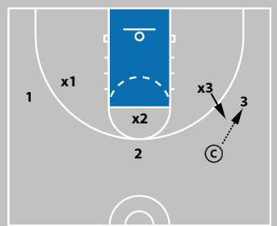

The coach has a ball. The drill starts when the coach passes the ball to 1, 2, or 3. The person guarding the player with the ball must get two feet outside the 3pt arc before they can defend. So if coach passes to 3, then X3 must move outside the 3pt arc and then start defending. This creates a momentary 3v2 advantage for the offense. The momentary advantage creates numerous teaching and skill development opportunities. Change possessions on made shots and defensive stops (turnovers or rebounds). Additional Rule: The offense can only shoot lay ups and 3pt shots. We add this rule (lay ups and 3s only) because it creates more passes, more outside shots, and gets players moving how we want in an actual 5v5 game (a real game has less space and more defenders on the court).
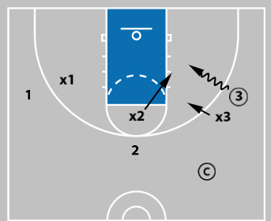

By playing 3v2 (a small sided game) players get far more passing, shooting, and decision making opportunities than in a 5v5 game. This is an excellent shooting drill that closely mimics how you will shoot in a real game. I can't tell you how effective this drill is when it comes to improving shooting, passing, decision making, defense and offense. However to get those results, it's important for coaches to "teach" and emphasize the following aspects... Coaching Points of Emphasis During this drill, coaches should emphasize the following:
- Close out fundamentals (for us that includes talk, sprint, chop feet, 1 hand up, then 2 hands out with wide defensive stance).
- Call out the shot and box out on every shot.
- If you have a lay up on the dribble drive, take that first (decision making on the drive).
- Accurate passes -- hit your teammate in the numbers so they can catch and shoot in rhythm.
- Offensive players off the ball, move to open windows (passing lanes) and force long close during the dribble drive. We want to force the defense to run as far as possible on close outs, yet stay in our shooting range. Too often players will compress to the ball instead of staying spaced during the dribble drive.
- Communicate constantly on defense... scramble as needed to get the ball stopped and contest all shots.

