Purpose of the Drill:
This is a great shooting warm up drill that you can use for practice or games. It works on lay ups, up and unders, floaters, front cuts, rear cuts, backdoor cuts, perimeter shooting, and attacking the basket.
This is also a great drill if you are limited on baskets and need to keep a lot of players involved.
Instructions
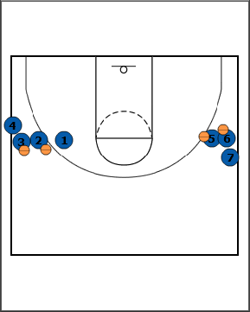
- Alignment
- Two lines.
- 4 Balls.
- First player does not have a ball.
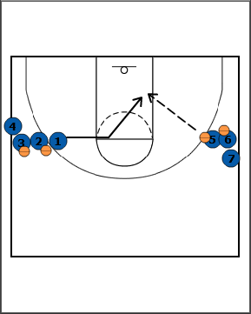
- Option 1 - Lay Ups
- 1 cuts towards the elbow, then cuts straight to the block.
- 5 passes 1 the ball.
- 1 shoots a lay up and gets the rebound.
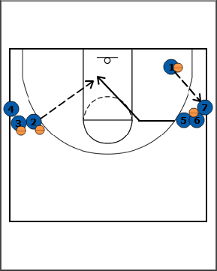
- After 5 passes, 5 cuts toward elbow, then straight to block.
- NOTE: The passer (5 in this case) cuts immediately after the pass. This quickens the pace of the drill for more shot repetitions.
- 2 passes to 5.
- 5 shoots the lay up and rebounds the ball.
- While 5 is cutting, 1 secured the ball, then passed and filled the ball to the opposite line.
- Variations / Progressions
- Some variations or progressions could be the up and under, jump hook, and dribble-spin.
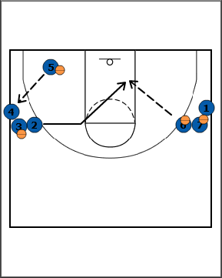
- After 2 passes, 2 cuts toward elbow, then straight to block.
- 6 passes to 2.
- 2 shoots the lay up and rebounds the ball.
- While 2 is cutting, 5 secured the ball, then passed and filled the ball to the opposite line.
- This motion continues over and over for the drill and the different options.
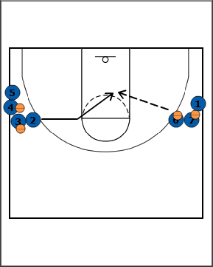
- Option 2 - Floater
- Now, the player will catch the ball 5 to 10 feet away from the basket and shoot a floater.
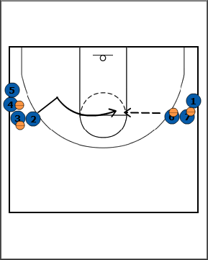
- Option 3 - Mid to Long Range Shot
- Now the player, will take two steps down, then cut to the opposite elbow.
- This can simulate running off of a screen or faking in the opposite direction in order to get open. The shot is usually 10 to 22 feet from the basket.
- You can adjust the shooting distance based on the level of your players.
- You can also have them move a couple of feet further from the basket after each round.
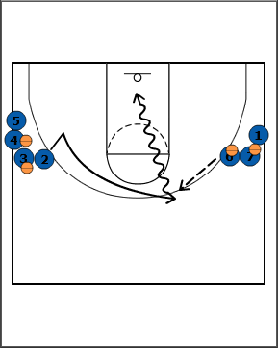
- Option 4 - Dribble Attack
- Now the player will catch and face, then step through and attack the basket.
- This simulates when the defender closes out hard to take away the shot and the ball handler drives by.
- Emphasize 1-dribble lay ups.
- Option 5 - Backdoor Cuts
- The player cuts high, then cuts backdoor for a lay up.
- Since we do lots of backdoor cuts in our offense, we include this in the warm up drill.
- You could also practice give and go cuts (front and rear cuts). However, this does slow down the pace of the drill, because the passer throws two passes. One on the initial cut to the top. The second pass on the give and go cut.
Points of Emphasis:
- On passes, have players use fakes to simulate game situations. For Lay Ups - Fake high, step through, bounce pass. Fake low, pass high.

